Name: ______________________________________ Date: ________________________

Student Exploration: Covalent Bonds

Vocabulary: covalent bond, diatomic molecule, Lewis diagram, molecule, noble gases, nonmetal, octet rule, shell, valence, valence electron

Covalent Bond - A covalent bond is a form of chemical bonding that is characterized by the sharing of pairs of electrons between atoms.

Diatomic Molecule - Diatomic molecules are molecules composed only of two atoms, of either the same or different chemical elements.

Lewis Diagram - Lewis structures (also known as Lewis dot diagrams, electron dot diagrams, and electron dot structures) are diagrams that show the bonding between atoms of a molecule and the lone pairs of electrons that may exist in the molecule.

Molecule - A molecule is an electrically neutral group of two or more atoms held together by covalent chemical bonds.

Noble Gases – The noble gases are a group of chemical elements with very similar properties: under standard conditions, they are all odorless, colorless, monatomic gases, with very low chemical reactivity.

Non Metal – A non-metal is an element on the periodic table that does not have the properties of a metallic element, such as malleability.

Octet Rule – The octet rule is a chemical rule of thumb that states that atoms of low (<20) atomic number tend to combine in such a way that they each have eight electrons in their valence shells, giving them the same electronic configuration as a noble gas.

Shell – Each shell is subdivided into subshells, which are made up of orbitals, each of which has electrons with different angular momentum.

Valence – "Valence" can be defined as the number of valence bonds a given atom has formed, or can form, with one or more other atoms.

Valence Electron - Valence electrons are the electrons of an atom that can participate in the formation of chemical bonds with other atoms.

Prior Knowledge Questions (Do these BEFORE using the Gizmo.)

- There are eight markers in a full set, but Flora and Frank each only have seven markers. Flora is missing the red marker, and Frank is missing the blue marker.

What can they do so that each has a full set of markers?

They can share the markers.

- Otto and Olivia each have six markers. Otto is missing the purple and green markers, and Olivia is missing the black and brown markers. What can they do so that each has a full set?

They can share the markers.

Gizmo Warm-up
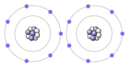
Just like the students described above, nonmetal atoms can share electrons. As you will see in the Covalent Bonds Gizmo™, atoms form bonds in this way.

To begin, check that Fluorine is selected from the Select a substance menu. Click Play () to see the electrons orbiting the nucleus of each atom.

- The outermost electrons in each atom are called valence electrons. How many valence electrons does each fluorine atom have? 7

- Click Pause (). Drag an electron from the left atom to the right atom. Click Play.

What happens? One electron from the left atom has an O orbital shared between the two atoms.

- Click Pause, drag an electron from the right atom to the left, and then click Play.

What happens now? One electron from the right atom has an O orbital shared between the two atoms.

Activity A:  Sharing electrons | Get the Gizmo ready:  - Click Reset.  - Select Hydrogen. | 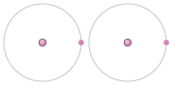

Introduction: The electrons that orbit the nucleus of an atom are arranged into shells. The first shell contains up to two electrons and the second contains up to eight electrons. Most elements are stable when they have eight valence electrons—a rule of thumb known as the octet rule. (Elements with less than five electrons are stable with two valence electrons.)

Question: What happens when atoms share electrons?

- Predict: Each hydrogen atom has one valence electron, but it needs two electrons to be stable. How can both hydrogen atoms each achieve a stable configuration?

One electron can be shared between the two atoms.

- Form a bond: Drag the electrons so that they move around both hydrogen atoms. Click Play to observe them in orbit, and then click Check. You have created a covalent bond.

Congratulations, you have completed a molecule of hydrogen! Because the molecule has two atoms, it is a diatomic molecule.

- In a Lewis diagram, dots represent unshared valence electrons and dashes represent pairs of shared electrons. Turn on Show Lewis diagram. Covalent bonds are shown in Lewis diagrams. Use the copy screen button to copy and paste a screen shot of the hydrogen molecule model and lewis diagram into your lab.

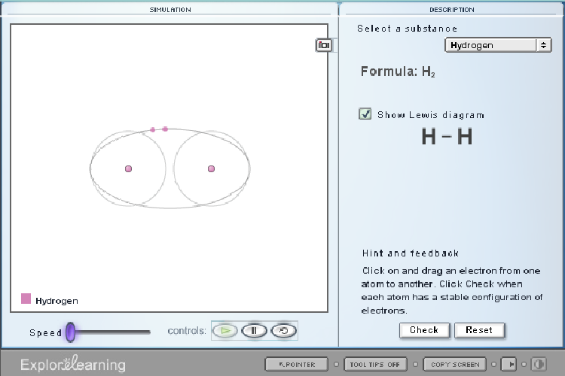

- Form a bond: Now select Fluorine and create a molecule of fluorine, F₂. Use the copy screen button to copy and paste a screen shot of the molecule with orbitals and the Lewis dot structure into your lab.

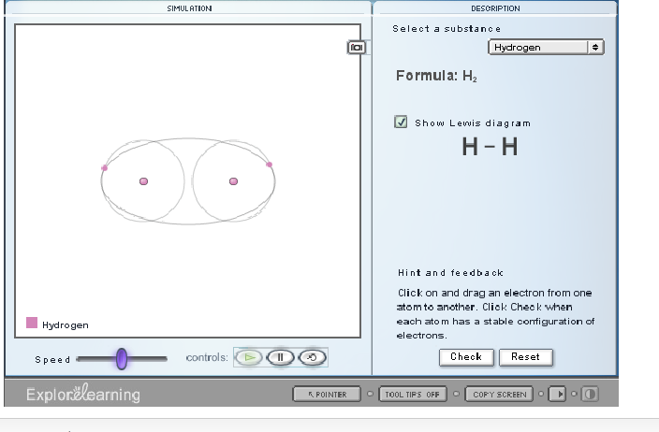

- Think and discuss: How is the formation of covalent bonds similar to kids sharing markers? How is it different?

The kids can have access to every color if they both share, similar to two molecules sharing electrons in a covalent bond.

Activity B:  Building molecules | Get the Gizmo ready:  - Click Reset.  - Turn off Show Lewis diagram.  - Select Oxygen. | 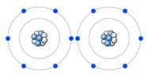

Question: How do atoms share more than one pair of electrons?

- Observe: Like fluorine and most other elements, oxygen atoms are most stable with a full complement of eight valence electrons.

  - How many valence electrons does each oxygen atom have now? 6

  - How many more electrons does each oxygen atom need to be stable? 2

- Form a bond: Drag electrons back and forth until the molecule of oxygen (O₂) is stable. Click Check to confirm your molecule is stable. Take a snapshot and paste the image into your document (don’t forget to label it “O₂”).

How many pairs of shared electrons are there in a stable molecule of oxygen? 2

- Use the copy screen button to paste a screenshot of the oxygen molecule and lewis dot structure into your lab.

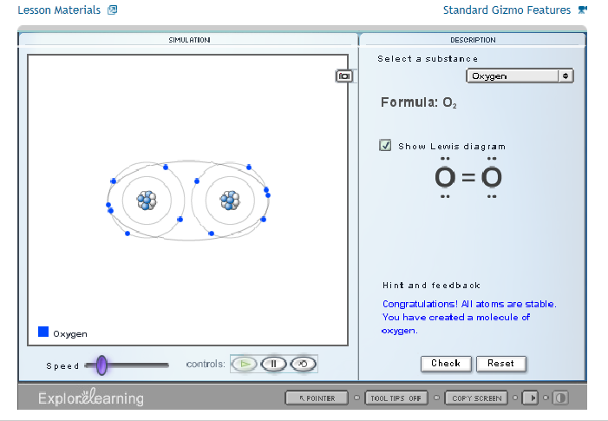

- Practice: Create covalent bonds and stable molecules for the remaining substances. Take a screenshot of the stable molecule and the lewis dot structure for each molecule.

Chlorine
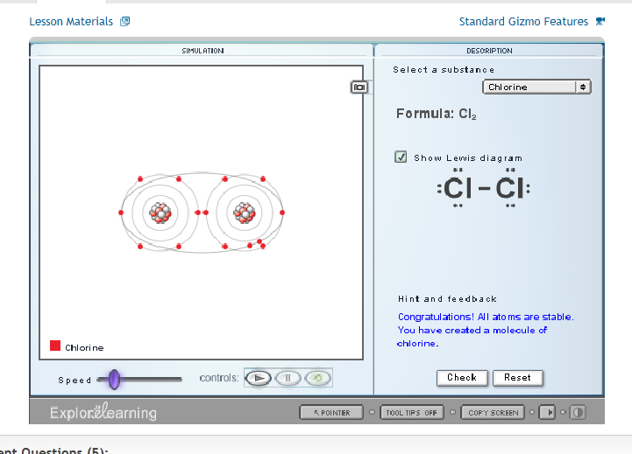

Water

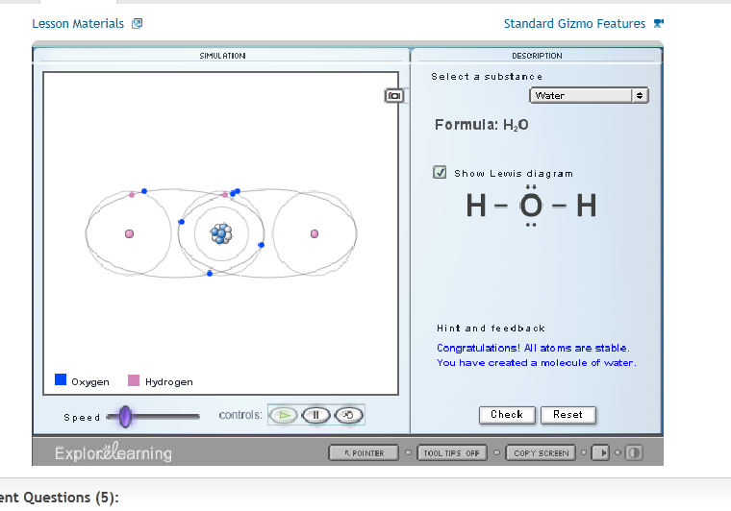

Ammonia

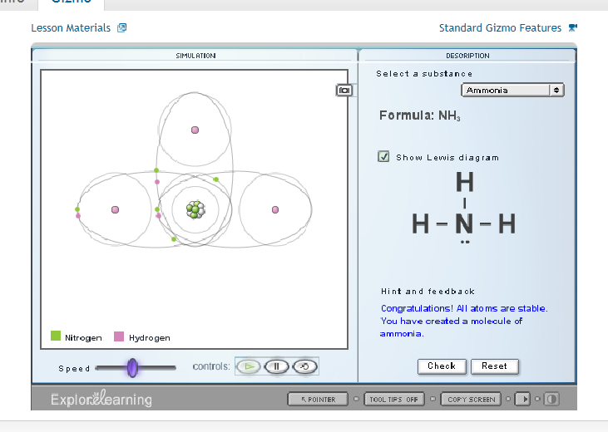

Methane

